**VIRTUAL PIANO**

**Capstone Project Report**

**Mid-Semester Evaluation**

**Submitted by:**

**(101683035) Akshay Sharma**

**(101683033) Abhi Mahajan**

**(101503008) Abhishek Sharma**

**BE Third Year, CSE**

**CPG No: 84**

Under the Mentorship of

**Dr Singara Singh**

**Associate Professor**



**Computer Science and Engineering Department**

**TIET, Patiala**

**MAY 2018**

**ABSTRACT**

Pianos are large instruments that cannot be carried everywhere. Even electric pianos need to be carried in a large bag and are prone to damage in travelling. So here we propose a portable virtual piano that just uses semi-transparent plastic sheet that can be carried and does not have any electronic components in it. We use a raspberry pi attached to a camera along with the plastic sheet to make a virtual piano. We use image processing to divide the plastic sheet into sections and assign particular tomes to it. We the detect human fingers through the plastic sheet and simulate associate piano tone for each section to play piano tones using a speaker. Thus, we provide a virtual piano which is actually a transparent light weight plastic board that can be carried around roughly.

**DECLARATION**

We hereby declare that the design principles and working prototype model of the project entitled Virtual Piano using Raspberry pi is an authentic record of our own work carried out in the Computer Science and Engineering Department, TIET, Patiala, under the guidance of Dr Singara Singh during 6th semester (2018).

Date: 30/05/2018

|  |  |  |
| --- | --- | --- |
| **Roll No.** | **Name** | **Signature** |
| 101683035 | Akshay Sharma |  |
| 101683033 | Abhi Mahajan |  |
| 101503008 | Abhishek Sharma |  |

*Counter Signed By:*

Faculty Mentor:

Dr. Singara Singh

Associate Professor

Computer Science & Engineering Department,

TIET, Patiala

**TABLE OF CONTENTS**

|  |  |
| --- | --- |
| **ABSTRACT** | ii |
| **DECLARATION** | iii |
| **TABLE OF CONTENTS** | iv |
| **LIST OF TABLES** | vi |
| **LIST OF FIGURES** | vii |
| **LIST OF ABBREVIATIONS** | viii |
| **1. INTRODUCTION** | 1 |
| 1.1 Project Overview | 1 |
| 1.2 Need Analysis | 5 |
| 1.3 Problem Definition and Scope of the Project | 6 |
| 1.4 Approved Objectives | 7 |
| 1.5 Methodology Used | 7 |
| 1.6 Assumptions | 8 |
| 1.7 Summary of Project Outcomes | 8 |
| 1.8 Project Schedule | 9 |
| **2. LITERATURE REVIEW** | 10 |
| 2.1 Background | 10 |
| 2.2 Existing System(s)/ Related Work | 11 |
| 2.3 Problem Identified | 13 |
| 2.4 Methods and Tools Used | 14 |
| **3. REQUIREMENT ANALYSIS** | 17 |
| 3.1 Software Requirement Specifications | 17 |
| 3.2 Cost Analysis | 17 |
| 3.3 Work Breakdown Structure | 18 |
| **4. DESIGN SPECIFICATIONS** | 19 |
| 4.1 Flowchart of proposed System | 19 |
| 4.2 Fabrication Sequence | 20 |
| 4.3 System Architecture | 21 |
| 4.4 User Interface Diagrams  4.5 System Components  4.6 Data Model  4.7 Snapshots of Working Prototype Model | 24  27  28  29 |
| **5. CONCLUSIONS AND FUTURE DIRECTIONS** | 31 |
| 5.1 Work Accomplished | 31 |
| 5.2 Conclusions | 31 |
| 5.3 Social/Economic Benefits  5.4 Reflections  5.5 Future Work Plan  **6. REFERENCES** | 31  32  32  33 |

**LIST OF TABLES**

|  |  |  |
| --- | --- | --- |
| **Table No.** | **Caption** | **Page No.** |
| Table 1 | Project Schedule | 7 |
| Table 2 | Gantt Chart | 7 |
| Table3 | Cost Analysis | 13 |

**LIST OF ABBREVIATIONS**

|  |  |
| --- | --- |
| **HGR** | Hand Gesture Recognition |
| **RGB** | Red Green Blue |
| **AR** | Augmented Reality |
| **FAQ** | Frequently Asked Questions |
| **HSV** | Hue Saturation Value |
| **TIET** | Thapar Institute of Engineering & Technology |
| **SD** | Secure Digital Card |
| **WBS** | Work Breakdown Structure |
| **DFD** | Data Flow Diagram |
| **BLOB** | Binary Linked Object |
| **LCD** | Liquid Crystal Display |
| **SDK** | Software Development Kit |
| **i.e.** | That is (Latin: Exempli Gratia) |
| **API** | Application Program Interface |

**LIST OF FIGURES**

|  |  |  |
| --- | --- | --- |
| **Figure No.** | **Caption** | **Page No.** |
| Figure 1 | Project Overview Design | 1 |
| Figure 2 | Work Breakdown Structure | 14 |
| Figure 3 | Flowchart of proposed System | 15 |
| Figure 4 | Fabrication Sequence | 16 |
| Figure 5 | Data Centered Architecture | 17 |
| Figure 6 | Data Flow Architecture | 18 |
| Figure 7 | Context Diagram | 19 |
| Figure 8 | Use Case Diagram | 20 |
| Figure 9 | Class Diagram | 21 |
| Figure 10 | Sequence Diagram | 22 |
| Figure 11 | System Components | 23 |
| Figure 12 | Data Model | 24 |

**INTRODUCTION**

* 1. **Project Overview**

Pianos are large instruments that cannot be carried everywhere. Even electric pianos need to be carried in a large bag and are prone to damage in travelling. So here we propose a portable virtual piano that just uses semi-transparent plastic sheet that can be carried and does not have any electronic components in it. We use a raspberry pi attached to a camera along with the plastic sheet to make a virtual piano. We use image processing to divide the plastic sheet into sections and assign particular tomes to it. We the detect human fingers through the plastic sheet and simulate associate piano tone for each section to play piano tones using a speaker. Thus, we provide a virtual piano which is actually a transparent light weight plastic board that can be carried around roughly.

Hand Gesture Recognition (HGR) is a very popular and effective way used for the human machine communication. It has been used in many applications including embedded systems, vision-based systems and medical applications. In HGR, fingertip detection is an important part if image base models are being used. HGR systems face many problems in skin segmentation due to luminance and intensity in images [1]. The fingertips detection models mostly have assumption about the hand direction; this restricts the natural expression of humans. Processing time is another key factor in image-based processing algorithms.

Here we are focusing on direction invariant fingertip detection of natural hand with real time performance. This work requires no glove, sensors or colour strips to detect the fingertips. The only assumption is that user will show the hand to system, facing the palm to the system while the direction of hand is not restricted. User is free to show hand in any direction as naturally hands move [11]. This report also presents a figure cropping method based on hand size, which will fasten the further process as the processing pixels would be reduced after cropping.

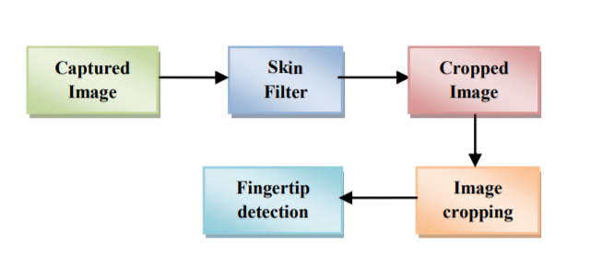

A lot of work has been done in this area for dynamic hand gesture recognition using fingertip detection. A survey on fingertip-based methods could be found out in. There are several limitations in existing approaches. Garg used 3D images in his method to recognize the hand gesture, but this process is complex and also not time efficient. The Processing time is one of the very critical factors in real time applications. Aznaveh presented an RGB vector-based method for skin detection in images. Yang analyses the hand contour to select fingertip candidates, then finds peaks in their spatial distribution and checks local variance to locate fingertips [6]. This method is not invariant to the orientation of the hand. There are other methods, which are using directionally Variant templates to detect fingertips. Few other methods are dependent on specialized instruments and setup like the use of infrared camera, stereo camera, a fixed background or use of markers on hand. This report describes a novel method of motion patterns recognition generated by the hand without using any kind of sensor or marker.

The fingertips detection should be near to real time if it is going to process video. Generally, image-based models work on pixel by pixel and do hand Segmentation and work only on region of interest [6]. However, most hand segmentation methods can’t do a clearly hand segmentation under some conditions like fast hand motion, cluttered background, poor light condition. If the hand segmentation is not valid, then detection of fingertips can be questionable. Researchers used infrared camera to get a reliable segmentation [10]. Few researchers in their work limit the degree of the background clutter, finger motion speed or light conditions to get a reliable segmentation. Raheja and few others also used 3D mapping using specialized device like KINECT for hand segmentation [2]. Some of fingertip detection methods can’t localize accurately multidirectional fingertips. Researchers assumed that the hand is always pointing upward to get precise localization.

Deaker proposed a piano tutoring system which would test the user’s knowledge by asking them to play particular notes or chords on a paper keyboard with a printed design [4]. Deaker’s proposal is similar to ours in that it requires the detection of the printed keyboard’s individual keys in order to determine if the user has followed instructions correctly. However, Deaker’s design has several limitations, perhaps the most significant of which being that the identification of keys is not entirely achieved by computer vision alone. A particular number of keys are required to be visible to the camera during calibration (14 white keys, starting from a C key and ending on the B key just under two octaves above) and the software assumes that this requirement has been met.

Another computer vision based piano tutor was proposed by Dawe [6]. In this case, the system is intended for relaying a student’s choice of fingering to their teacher during a remote piano lesson. Similarly, to Deaker’s proposal, Dawe’s method requires a calibration stage where the user is required to select a region of interest – in order to narrow the video frames down to the area occupied by the instrument’s keyboard. This brings with it the same limitations imposed by Deaker’s method; that is the camera must remain stationary at all times, and the keyboard must not be obscured during the calibration process.

To find the key locations during the calibration phase, Dawe used horizontal and vertical edge detection to determine the boundaries of the keyboard and its individual keys. Unfortunately, a major limitation of Dawe’s method was that a translation between these detected edges and a description of the location of each key of the keyboard was unable to be implemented.

After examining these proposed methods, it was clear that a satisfactory method of keyboard and key detection had not been found. The following works were more successful in their attempts to detect individual piano keys.

The work by Barakonyi and Schmaltzier demonstrates a variety of 3D augmented reality (AR) applications, including the Augmented Piano Tutor application [2]. The application displays an AR overlay on the user’s electronic keyboard, indicating which keys are to be played.

The method proposed by Gorodnichy and Yogeswaran attempts to solve the same problem as identified by Dawe; that is, Gorodnichy and Yogeswaran present a solution to allow current remote piano teaching systems to communicate fingering information [4]. There is one major limitation of Gorodnichy and Yogeswaran’s method; the camera used is not an off-the-shelf webcam, but instead a more expensive video camera with high quality output and zoom functionality is required.

The final keyboard detection method we shall discuss is from a paper by Huang, Zhou, Yu, Wang and Du [3], where a marker less AR piano system is proposed. The 3D AR result is very similar to that achieved by Barak Onyi and Schmaltzier, although in this case a fiducial marker is not required. To identify the keys of the keyboard, a similar method to that of Gorodnichy and Yogeswaran is employed. After identifying the piano keys, this solution uses OpenGL to augment the video stream with 3D graphics.

This was seemed to accomplish almost all of what we were setting out to achieve. Consequently, the work by Huang, Zhou, Yu, Wang and Du is regarded as a target result for our paper, with our application intended to match the results produced by the marker less AR piano system as best as possible. More specifically, the system by Huang et al. managed the keyboard identification and rendering of the video feed, with overlays, at a frame rate of approximately 15 frames per second [6]. We hoped to match or exceed this performance with our solution.

As a final note on the system developed by Huang et al., there is a small way in which the design could arguably be improved upon: The marker less AR piano system requires a one-time calibration for each camera and/or piano used, and for the 3D registration to be possible, the dimensions of the keyboard need to be known by the software [13]. This requires that the user manually measure their piano keyboard, then input the information into the AR program. At the expense of 3D augmentations, this potential inconvenience can be removed.

* 1. **Need Analysis**

Piano is almost certainly the largest and most complex mechanical device. A standard piano has 230 strings and about 10,000 separate moving parts. Over the last decade, alternatively sized keyboards have become available in a very limited way. At the same time, various academics, researchers and manufacturers such as Steinbuhler & Company have started to raise awareness and discuss the possibility that the current size keyboard is not ideal for all, and that keyboards with narrower keys may well suit the majority of the population [5]. However, they encounter considerable resistance to contemplate change from the ‘one-size suits all’ mentality. A major disincentive for a pianist wanting to switch to a keyboard of a different size is that they are not available - in practical terms every piano keyboard anywhere is the standard size. Major piano manufacturers do not produce pianos with narrower keys, except perhaps as a rare, ‘special’ order. A handful of small manufacturers can and do, but not in enough supply: small-scale production, logistics and cost prohibit worldwide access. The plight of pianists who do have reduced size keyboards at home illustrates the complexities [7]. While they may reach a very high standard with challenging repertoire on the narrower keys, away from their own keyboard the only option are pianos with the standard keys – meaning that they struggle to play many pieces as well and have to drop some of their repertoire completely. To play outside their home they will need easy access to a 'standard' keyboard for practice – options include a grand piano with interchangeable keyboards or acquiring a standard keyboard in a good quality digital piano. As keyboards with narrower keys become more widely accepted and accessible in the community this problem will be reduced.

With the skyrocketing costs of new pianos over the past decade or two, the prices of used pianos have increased dramatically.  Another upward pressure on the cost of a used piano is that there are fewer good used pianos available.  A large portion of the big old uprights are now old enough that they have serious mechanical problems which cost more to repair than they are worth so they are being scrapped [1].  Many of the less expensive pianos built in the 60's and 70's are also coming to the end of their useful life and are being taken to the dump or scrapped.  15-20 years ago, a really good used piano could be purchased for $ 300-500 and something that held tune and played could be purchased for $ 100-200.

Today, the piano buyer needs to expect to pay a minimum of $ 1,200-1,500 for a piano that will hold tune and plays reasonably well and doesn't look horrible in your living room.  Most used pianos that are for sale are on the market because the family has lost interest in playing the piano.  Since there has been no interest in it, it probably has not been tuned or cared for in several years.  The piano buyer needs to keep in mind that they will have to remedy that neglect once the piano is moved to their home [7].  It is possible that the piano has fallen way below standard pitch and will require a pitch raise (see FAQ "What is a Pitch Raise") to bring it back into tune. That pitch raises and 1st tuning could cost close to $ 200.  It is also possible that the piano has not been cleaned or regulated in many years (it is not surprising to find that a piano has NEVER been serviced) so that is doesn't play very smoothly or responsively.  Cleaning and regulating a vertical piano can cost around $ 400.

The greatest risk in purchasing a used piano is in whether it will hold tune or not.  There is much less risk in buying a piano that has been tuned regularly and the service records are available.  That is not a guarantee that it will continue to hold tune in the future but is certainly a good indicator.  The buyer should be willing to pay significantly more for such an instrument than one that has not had any care for a number of years [3]. A piano technician can make an educated guess as to the condition of a piano in a brief visit, but without a history of working with the instrument, it is but an educated guess.

* 1. **Problem Definition and Scope of the Project**

Moving piano from one home to another without the utmost care can easily cause unforeseen problems. Hence Pianos are large instruments that cannot be carried everywhere. Even electric pianos need to be carried in a large bag and are prone to damage in travelling. Today, the piano buyer needs to expect to pay a minimum of $ 1,200-1,500 for a piano that will hold tune and plays reasonably well and doesn't look horrible in your living room.  Most used pianos that are for sale are on the market because the family has lost interest in playing the piano.

So here we propose a portable virtual piano that just uses semi-transparent plastic sheet that can be carried and does not have any electronic components in it. The solution mainly focuses on the cost and budget of the Music Enthusiastic. Virtual Piano will reduce the problem of carrying large sized pianos. The Scope of the project mainly focuses on the following things: -

1. Large Pianos are prone to damage in travelling and these Virtual Pianos will take care of this issue.
2. Virtual Pianos will be much cheaper than traditional pianos.
3. It will help young children to get a feel for music and will act as a stepping stone for some of the world’s greatest artists.
   1. **Approved Objectives**
4. Assigning the respective tones of piano to the corresponding segments of Virtual Piano made using semi-transparent plastic sheet.
5. Real time motion detection of fingers using a camera linked with Raspberry pi.
6. To play the tone assigned to a segment on detection of finger on that particular Segment.
   1. **Methodology Used**

Pianos are large instruments that cannot be carried everywhere. Even electric pianos need to be carried in a large bag and are prone to damage in travelling. So here we propose a portable virtual piano that just uses semi-transparent plastic sheet that can be carried and does not have any electronic components in it. We use a raspberry pi attached to a camera along with the plastic sheet to make a virtual piano. We use image processing to divide the plastic sheet into sections and assign particular tomes to it. We then detect human fingers through the plastic sheet and simulate associate piano tone for each section to play piano tones using a speaker. Thus, we provide a virtual piano which is actually a transparent light weight plastic board that can be carried around roughly.

We propose a method for identifying a piano keyboard present in the video footage of a standard webcam with the goal of teaching chords, scales and suggested finger positions to a beginner pianist. Our keyboard identification method makes use of binary thresholding, Sobel operators and Hough transforms, as well as proposed algorithms specific to this application, to first find an area resembling a piano keyboard before narrowing the search to detect individual keys [9]. Through the use of our method the keys of a piano keyboard were successfully identified from webcam video footage, with a tolerance to camera movement and occluded keys demonstrated. This result allowed the augmented reality style highlighting of individual keys, and the display of suggested fingering, for various chords and scales.

* 1. **Assumptions**

1. Camera should be mounted properly.
2. The camera should be mounted in such a way such that it focusses on each segment properly.
3. The camera should be calibrated before the system starts.
4. The piano should be set up in bright lighting conditions.
5. The size of the piano will depend on the coverage area of camera.
6. The system should fulfil all the basic requirements needed for the project.
   1. **Summary of Project Outcomes**
7. Large Pianos are prone to damage in travelling and these Virtual Pianos will take care of this issue.
8. Virtual Pianos will be much cheaper than traditional pianos.
9. It will help young children to get a feel for music and will act as a stepping stone for some of the world’s greatest artists.
   1. **Project Schedule**

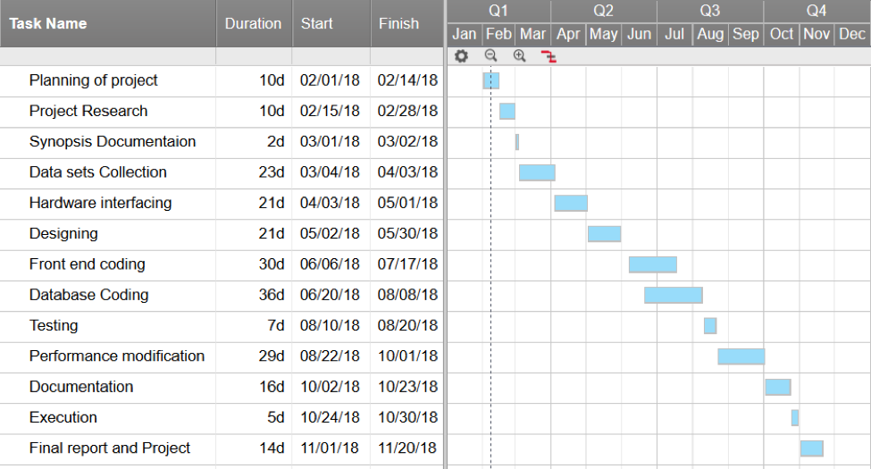

Scheduling all the tasks in Project Schedule using Gantt Chart

**LITERATURE REVIEW**

**2.1 Background**

A lot of work has been done in this area for dynamic hand gesture recognition using fingertip detection. A survey on fingertip-based methods could be found out in. There are several limitations in existing approaches. Garg used 3D images in his method to recognize the hand gesture, but this process is complex and also not time efficient. The Processing time is one of the very critical factors in real time applications. Aznaveh presented an RGB vector-based method for skin detection in images. Yang analyses the hand contour to select fingertip candidates, then finds peaks in their spatial distribution and checks local variance to locate fingertips. This method is not invariant to the orientation of the hand. There are other methods, which are using directionally Variant templates to detect fingertips. Few other methods are dependent on specialized instruments and setup like the use of infrared camera, stereo camera,

a fixed background or use of markers on hand. This paper describes a novel method of motion patterns recognition generated by the hand without using any kind of sensor or marker.

The fingertips detection should be near to real time if it is going to process video. Generally, image-based models work on pixel by pixel and do hand Segmentation and work only on region of interest. However, most hand segmentation methods can’t do a clearly hand segmentation under some conditions like fast hand motion, cluttered background, poor light condition. If the hand segmentation is not valid, then detection of fingertips can be questionable. Researchers used infrared camera to get a reliable segmentation. Few researchers in their work limit the degree of the background clutter, finger motion speed or light conditions to get a reliable segmentation. Raheja and few others also used 3D mapping using specialized device like KINECT for hand segmentation. Some of fingertip detection methods can’t localize accurately multidirectional fingertips. Researchers assumed that the hand is always pointing upward to get precise localization.

**2.2 Related Work**

We began by examining the recent papers from the University of Canterbury, where work, similar to that proposed in this paper, has been developed in the past. For example, Lang produced a webcam-based piano application – however the focus of this was on entertainment, not education, and there was no attempt made to detect the keyboard or keys of a real piano.

Deaker proposed a piano tutoring system which would test the user’s knowledge by asking them to play particular notes or chords on a paper keyboard with a printed design [4]. Deaker’s proposal is similar to ours in that it requires the detection of the printed keyboard’s individual keys in order to determine if the user has followed instructions correctly. However, Deaker’s design has several limitations, perhaps the most significant of which being that the identification of keys is not entirely achieved by computer vision alone. A particular number of keys are required to be visible to the camera during calibration (14 white keys, starting from a C key and ending on the B key just under two octaves above) and the software assumes that this requirement has been met.

Another computer vision based piano tutor was proposed by Dawe [6]. In this case, the system is intended for relaying a student’s choice of fingering to their teacher during a remote piano lesson. Similarly, to Deaker’s proposal, Dawe’s method requires a calibration stage where the user is required to select a region of interest – in order to narrow the video frames down to the area occupied by the instrument’s keyboard. This brings with it the same limitations imposed by Deaker’s method; that is the camera must remain stationary at all times, and the keyboard must not be obscured during the calibration process.

To find the key locations during the calibration phase, Dawe used horizontal and vertical edge detection to determine the boundaries of the keyboard and its individual keys. Unfortunately, a major limitation of Dawe’s method was that a translation between these detected edges and a description of the location of each key of the keyboard was unable to be implemented.

After examining these proposed methods, it was clear that a satisfactory method of keyboard and key detection had not been found. The following works were more successful in their attempts to detect individual piano keys.

The work by Barakonyi and Schmaltzier demonstrates a variety of 3D augmented reality (AR) applications, including the Augmented Piano Tutor application [2]. The application displays an AR overlay on the user’s electronic keyboard, indicating which keys are to be played.

Unfortunately, the paper by Barak Onyi and Schmaltzier does not describe their implementation details – making it difficult to learn any lessons from their AR solution. However, some of their high-level implementation is explained, and even from this it is possible to suggest some improvements – albeit minor ones. The Augmented Piano Tutor application makes use of AR Toolkit for 3D registration. The use of AR Toolkit means that a fiducial marker is required as a reference point for the application. It would be most convenient for the user if they did not have to correctly place a marker or do any more than set up their webcam and laptop, to use a tutoring program. An ideal system would allow the user to simply run an application, point their webcam at a keyboard, and begin playing.

The method proposed by Gorodnichy and Yogeswaran attempts to solve the same problem as identified by Dawe; that is, Gorodnichy and Yogeswaran present a solution to allow current remote piano teaching systems to communicate fingering information [12]. There is one major limitation of Gorodnichy and Yogeswaran’s method; the camera used is not an off-the-shelf webcam, but instead a more expensive video camera with high quality output and zoom functionality is required.

The final keyboard detection method we shall discuss is from a paper by Huang, Zhou, Yu, Wang and Du, where a marker less AR piano system is proposed. The 3D AR result is very similar to that achieved by Barak Onyi and Schmaltzier, although in this case a fiducial marker is not required [8]. To identify the keys of the keyboard, a similar method to that of Gorodnichy and Yogeswaran is employed. After identifying the piano keys, this solution uses OpenGL to augment the video stream with 3D graphics.

This was a paper that seemed to accomplish almost all of what we were setting out to achieve. Consequently, the work by Huang, Zhou, Yu, Wang and Du is regarded as a target result for our paper, with our application intended to match the results produced by the marker less AR piano system as best as possible. More specifically, the system by Huang et al. managed the keyboard identification and rendering of the video feed, with overlays, at a frame rate of approximately 15 frames per second. We hoped to match or exceed this performance with our solution.

As a final note on the system developed by Huang et al., there is a small way in which the design could arguably be improved upon: The marker less AR piano system requires a one-time calibration for each camera and/or piano used, and for the 3D registration to be possible, the dimensions of the keyboard need to be known by the software. This requires that the user manually measure their piano keyboard, then input the information into the AR program. At the expense of 3D augmentations, this potential inconvenience can be removed.

**2.3 Problem Identified**

Moving piano from one home to another without the utmost care can easily cause unforeseen problems. Hence Pianos are large instruments that cannot be carried everywhere. Even electric pianos need to be carried in a large bag and are prone to damage in travelling.

Today, the piano buyer needs to expect to pay a minimum of $ 1,200-1,500 for a piano that will hold tune and plays reasonably well and doesn't look horrible in your living room. Most used pianos that are for sale are on the market because the family has lost interest in playing the piano.

So here we propose a portable virtual piano that just uses semi-transparent plastic sheet that can be carried and does not have any electronic components in it. The solution mainly focuses on the cost and budget of the Music Enthusiastic [14]. Virtual Piano will reduce the problem of carrying large sized pianos.

**2.4 Methods and Tools used**

Video is the sequence of the image frames at a fixed rate. First of all, Images would be captured with a simple camera in 2D continuously and would be processed one by one. An HSV colour space-based skin filter would be applied on the images for hand segmentation. An intensity-based histogram would be constructed for the wrist end detection and image would be cropped so that resultant image would have only hand pixels. The fingertips would be detected in the cropped hand image and would be marked differently.

**Skin Filter**

An HSV colour space-based skin filter would be used on the current image frame for hand segmentation. The skin filter would be used to create a binary image with black background. This binary image would be smoothened using the averaging filter. There can be false positives, to remove these errors the biggest BLOB (Binary Linked Object) is considered as the hand and rest are background. The biggest BLOB represents hand coordinates “1” and “0” to the background [4]. The filtered-out hand image, after removing all errors. The only limitation of this filter is that the BLOB for hand should be the biggest one.

**Wrist End Detection**

To crop the image, we need to find out the direction of hand and wrist end. First of all, an intensity histogram of the binary silhouette would be formed. Histograms functions are: Here imb represents the binary silhouette and m, n represents the row and columns of the matrix imb.

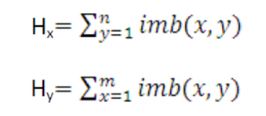

To find the direction of hand, after a 4-way scan of image, we choose the maximum value of „on‟ pixels coming out of all scans (“1” in the binary silhouette). it was noted that maximum value of “ON” pixels represents wrist end and opposite end of this scan end would represent the finger end. Similarly, the green bar corresponds to right scan, red bar corresponds to down scan, and pink bar corresponds to up scan of „on‟ pixels in the binary silhouette. Now, it is clear that red bar has higher magnitude than other bars. So, we can infer that the wrist end is in downward direction of the frame and consequently the direction of fingers is in the upward direction [8]. Here the direction from wrist to finger is known.

**Hand Cropping**

Hand cropping minimizes the number of pixels to be taken into account for processing which leads to minimization of computation time. In the histogram generated, it was observed that at the point where wrist ends, a steeping inclination of the magnitude of the histogram starts, whose slope, m can be defined as:

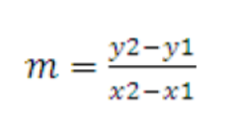

The scan would start from the end where skin pixel was found and move till an inclination would be found. The points correspond to the first skin pixel scanning from other three sides were found, crop the image at that points. The equations for cropping the image are:

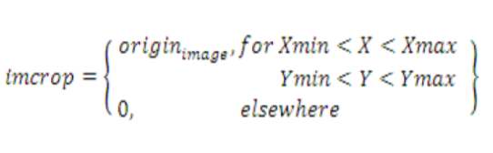

Where imcrop represents the cropped image, Xmin, Ymin, Xmax, Ymax represent the boundary of the hand in the image. Some results with processing steps for hand cropping. The arrows showed in the main frames indicate the direction of scan which was found from wrist end detection step [7]. In all the histograms it is clear that at the wrist point, a steeping inclination starts in the scanning direction.

**Fingertip Detection**

At this point we have one smaller image which conation only skin pixels (hand gesture shape). We will figure out fingertips in the cropped hand image. Start scan the cropped binary image from wrist to fingers end and calculate the number of pixels for each row or column based on the hand direction in up-down or left-right. Assign the intensity values for each pixel from 1 to 255 in increased manner from wrist to finger end in equal distribution. So, each “on” pixel on the edges of the fingers would be assigned a high intensity value of 255. Hence all the fingertips contain pixel value 255. The fingertip detection can be represented mathematically as;

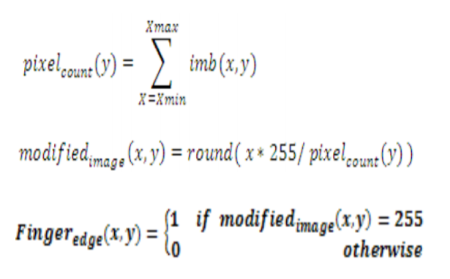

The line having high intensity pixel, is first indexed and check whether differentiated value lie inside a threshold, if it is then it represents a fingertip. The threshold value changes toward the direction of hand. That threshold can be set after the detection of the direction of hand to the finger which we already know. where detected pixels are marked with different color. any direction, only palm should face the camera [11]. The fingertips would be detected irrespective of user orientation. The Movement of user’s finger will control the robot hand and its working, by moving hand in front of camera without wearing any gloves or markers.

**REQUIREMENT ANALYSIS**

**3.1 Software Requirement Specification**

**Functional Requirements**

* The system should do segment detection on the basis of finger’s motion.
* The system should simulate associated piano tone based on the segment detected.
* The system shall allow the user to play music as per his/her requirements.
* The system shall give different sound based on the selected Instrument which is listed in a combo box.
* The system should handle the problem of system failure using an LCD display.
* The size of the transparent sheet should accommodate all the notes of the piano.
* The developer can maintain and update the system by reinstalling the current system.

**Non-Functional Requirements**

* Performance: The response time of the system must be fast and smooth.
* Reliability: No error will encounter while user is using the application.
* Ease of use: A good design interface should be constructed with easy control and friendly user interface.
* Accurate: The system should play the correct piano tone by detecting the segment accurately.

**3.2 Cost Analysis**

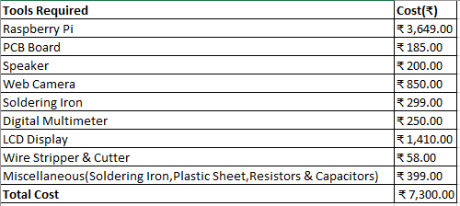

**3.3 Work Breakdown Format**

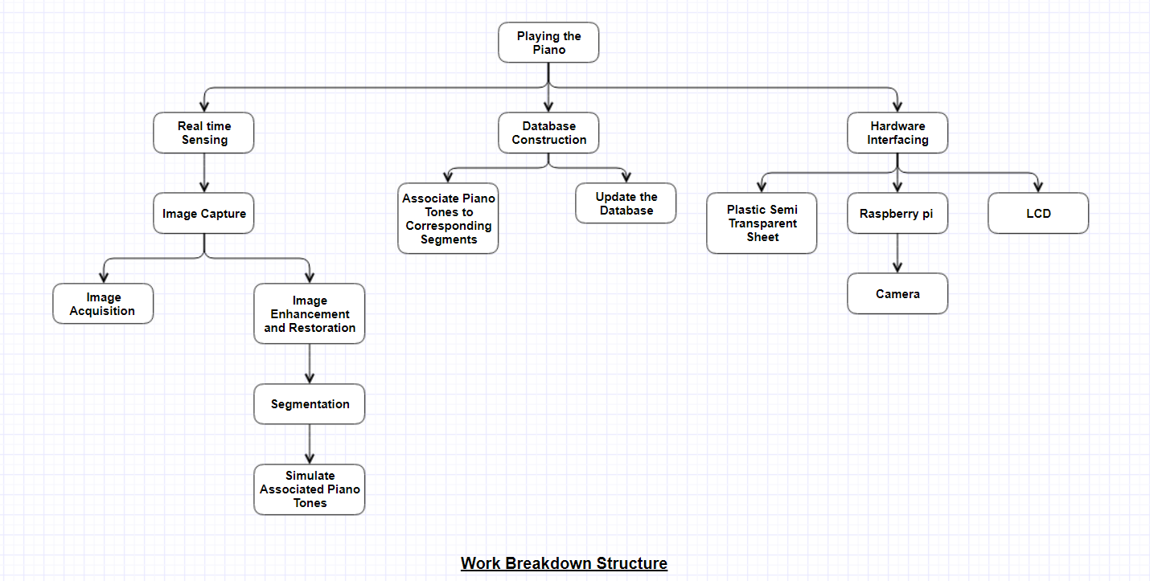

**DESIGN SPECIFICATIONS**

**4.1 Flowchart of the proposed system**

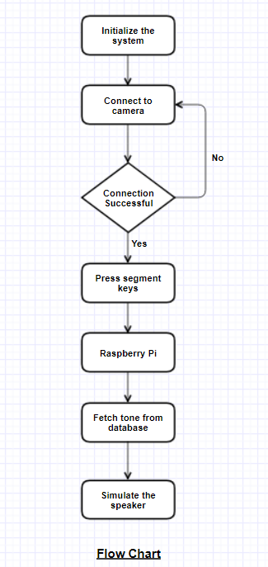

**4.2 Fabrication Sequence**

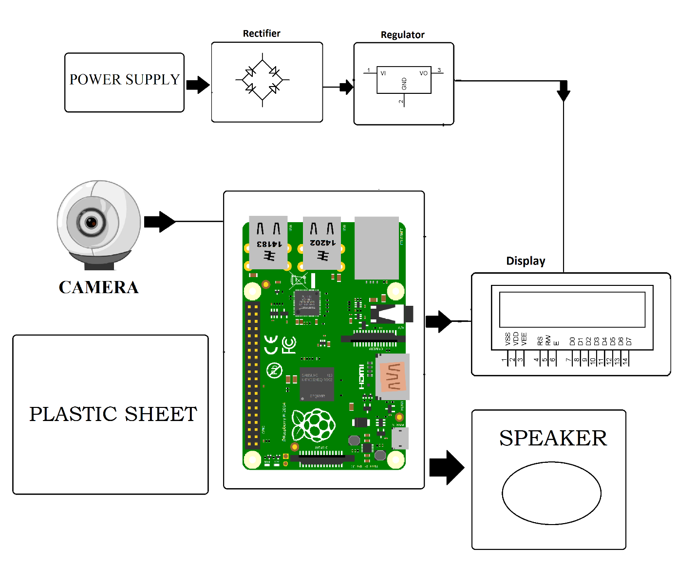

**4.3 System Architecture**

1. Data centered architecture

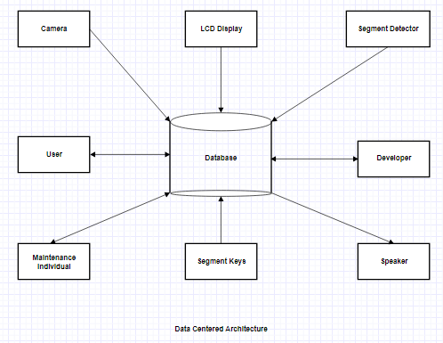

1. Data Flow Architecture

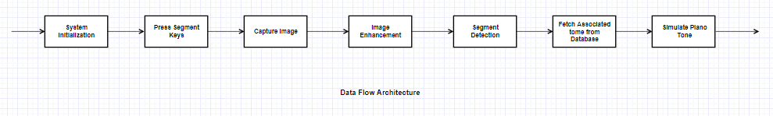

1. Context Diagram

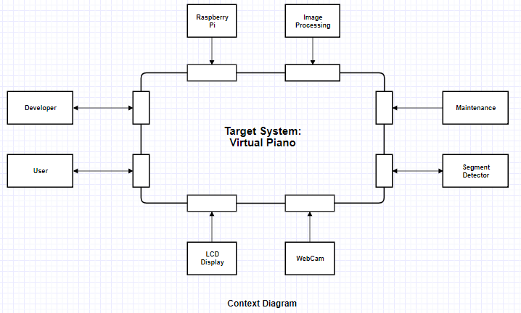

**4.4 User Interface Diagrams**

1. Use case diagram

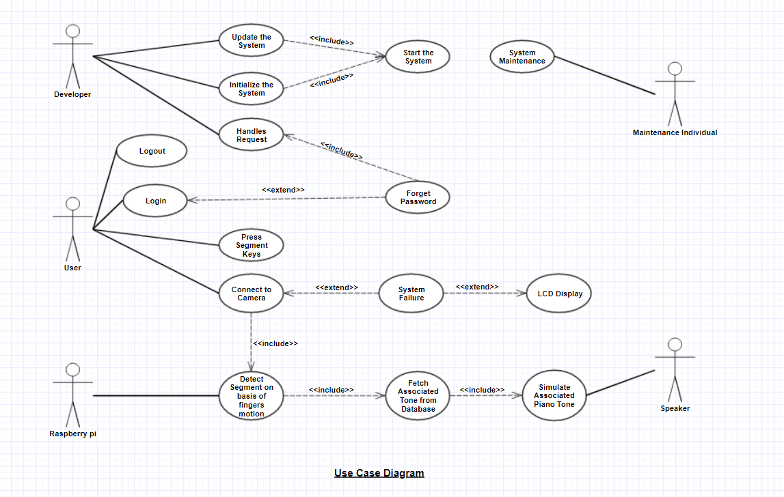

1. Class Diagram

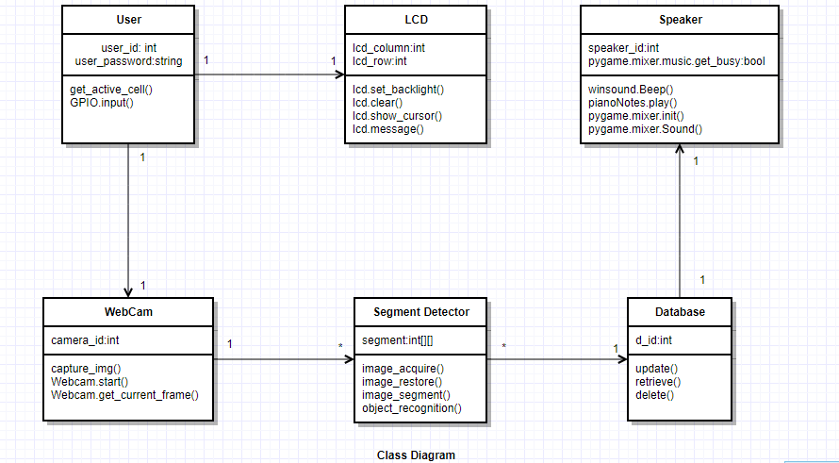

1. Sequence Diagram

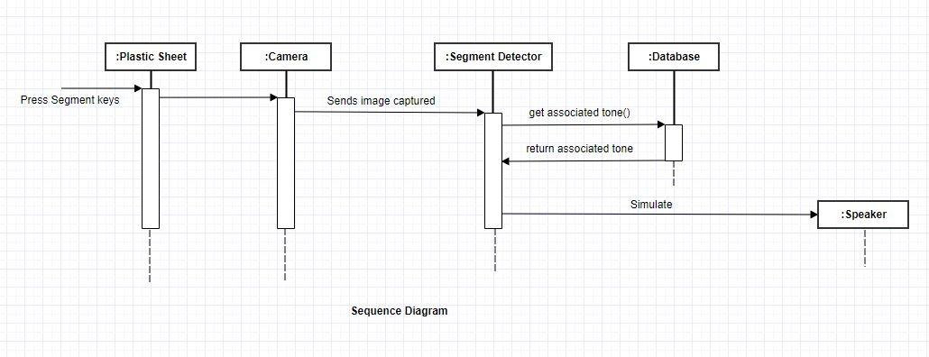

* 1. **System Components**

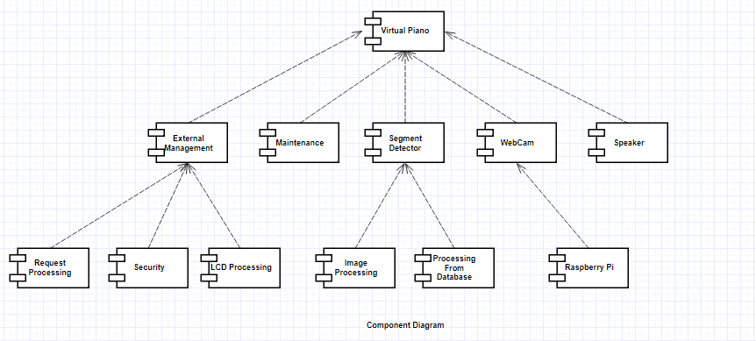

* 1. **Data Model**

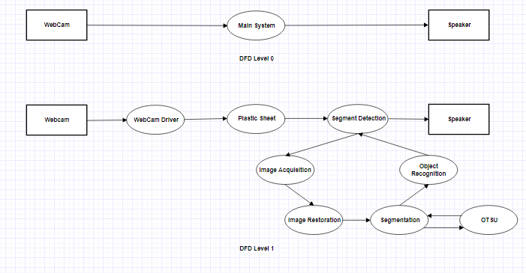

**4.7 Snapshots of Working prototype Model**

1. Semi Transparent Plastic Sheet

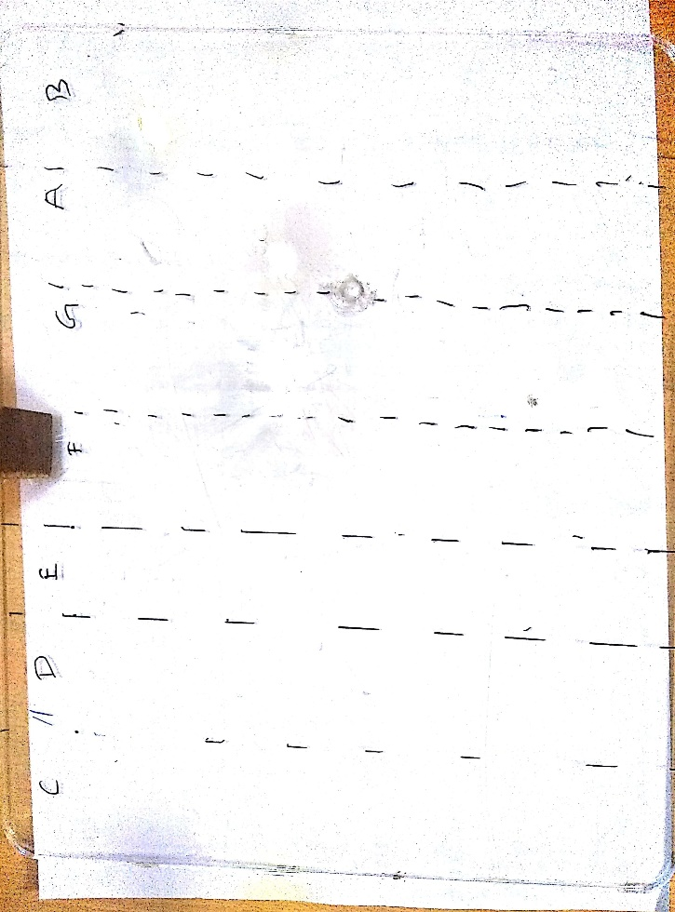

1. Camera attached on wooden mount

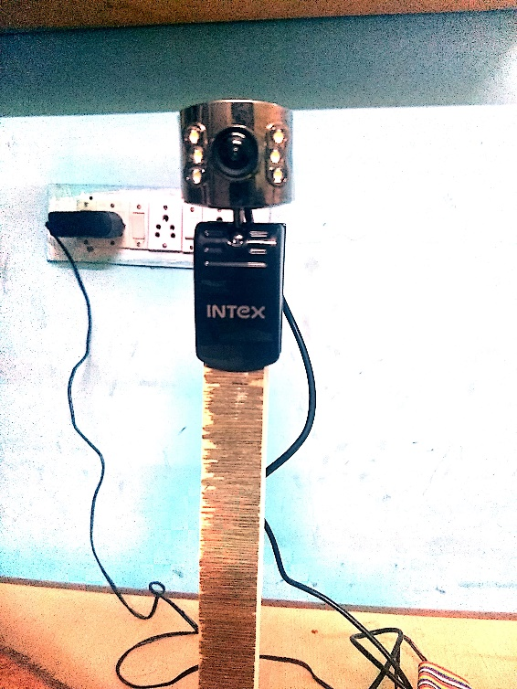

1. 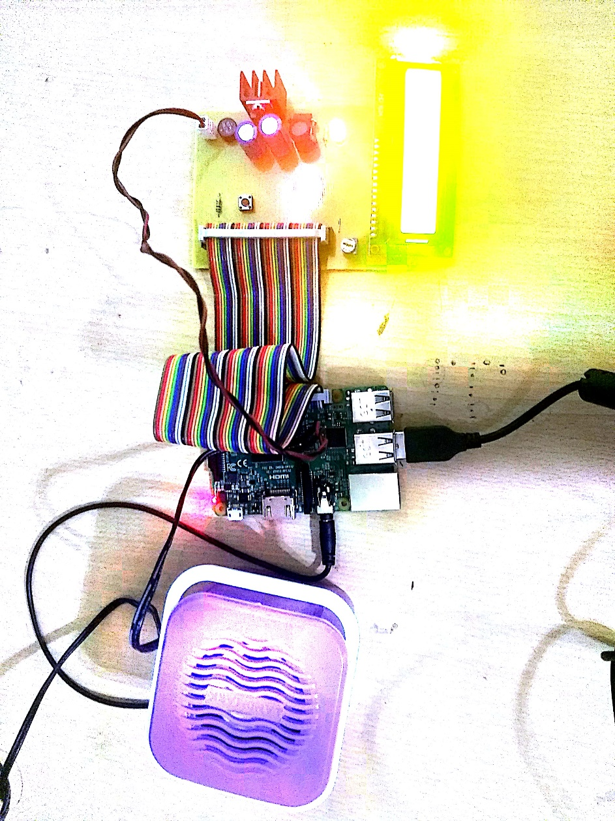Speaker, Raspberry pi and LCD Display

**CONCLUSIONS AND FUTURE DIRECTIONS**

**5.1 Work Accomplished**

1. Finalized System Requirement Specification with finalized analysis model i.e. Use Case Diagrams, Class Diagrams, Data Flow Diagram and Sequence Diagram.
2. Finalized our design model consisting of Data Centered Architecture, Data Flow Architecture, Component Diagram and Context Diagram.
3. Soldering of components based on the circuit diagrams decided earlier.
4. Organized all the components based in the circuit diagram.
5. Finger detection and simulation of a piano tone.

5.2 Conclusion

This project is a great example of how the use of Raspberry Pi and Pi camera with Open CV's computer vision algorithms can do wonders in security standards. By compiling the latest version of Open CV, we got access to the latest and most interesting computer vision algorithms like finger recognition.

5.3 Social/Economic Benefits

1. We propose a portable virtual piano that just uses semi-transparent plastic sheet that can be carried anywhere and does not have any electronic components in it.
2. Large Pianos are prone to damage in travelling and these Virtual Pianos will take care of this issue.
3. Virtual Pianos will be much cheaper than traditional pianos.
4. It will help young children to get a feel for music and will act as a stepping stone for some of the world’s greatest artists.

**5.4 Reflections**

1. Understood the workings of Raspberry Pi in detail.
2. Understood the implementation of Ada fruit in Python.
3. Understood the implementation of pygame library in Python.
4. Become proficient in working as an enthusiastic team

**5.5 Future work plan**

1. Code optimization to improve real time sensing.
2. Improved prototype with proper casing to give it a finishing and premium look.
3. Investigate using other real time sensing algorithms in OpenCV which might be more robust to varied lighting or other conditions.

**REFERENCES**

[1] A. Oka and M. Hashimoto, "Marker-less piano fingering recognition using sequential depth images," in Frontiers of Computer Vision, (FCV), 2013 19th Korea-Japan Joint Workshop on, 2013, pp. 1-4.

[2] B. Kraemer. (N.D.). Major Piano Triad Chords [Online]. Available: http://piano.about.com/od/chordskeys/ss/major_triads_treble.htm

[3] C.-C. Lin and D. S.-M. Liu, "An intelligent virtual piano tutor," presented at the Proceedings of the 2006 ACM international conference on Virtual reality continuum and its applications, Hong Kong, China, 2006.

[4] C. Deaker and R. Green, "A Computer Vision Method of Piano Tutoring, Without the Piano," Canterbury University 2011.

[5] C.-H. Yeh, W.-Y. Tseng, J.-C. Bai, R.-N. Yeh, S.-C. Wang, and P.-Y. Sung, "Virtual Piano Design via Single-View Video Based on Multifinger Actions Recognition," in Human-Centric Computing (HumanCom), 2010 3rd International Conference on, 2010, pp. 1-5.

[6] E. Dawe and R. Green, "Computer Vision Piano Tutor," Canterbury University 2010.

[7] F. Huang, Y. Zhou, Y. Yu, Z. Wang, and S. Du, "Piano AR: A Markerless Augmented Reality Based Piano Teaching System," in Intelligent Human-Machine Systems and Cybernetics (IHMSC), 2011 International Conference on, 2011, pp. 47-52.

[8] J. Savard. (N.D., 04/05/2013). The Size of the Piano Keyboard [Online]. Available: http://www.quadibloc.com/other/cnv05.htm

[9] K. Huang, E. Y. L. Do, and T. Starner, "PianoTouch: A wearable haptic piano instruction system for passive learning of piano skills," in Wearable Computers, 2008. ISWC 2008. 12th IEEE International Symposium on, 2008, pp. 41-44.

[10] M. Sotirios and P. Georgios, "Computer vision method for pianist's fingers information retrieval," presented at the Proceedings of the 10th International Conference on Information Integration and Web-based Applications & Services, Linz, Austria, 2008.

[11] M. Lang and R. Green, "Musical Desktop: A Webcam Piano," Canterbury University 2012.

[12] D. O. Gorodnichy and A. Yogeswaran, "Detection and tracking of pianist hands and fingers," in Computer and Robot Vision, 2006. The 3rd Canadian Conference on, 2006, pp. 63-63.

[13] N. Wickham. (2010, 04/05/2013). Free Piano Scale Fingering Diagrams [Online]. Available: http://musicmattersblog.com/2010/04/06/free-pianoscale-fingering-diagrams/

[14] R. Kelley. (2001, 04/05/2013). Scale Fingering Chart [Online]. Available: http://www.robertkelleyphd.com/scalfing.htm